SummaryTables Version 1.7
Contents
Function of the SummaryTables Module 1
Simulation Setup 2
Required Variables by Module 4
Unit Definition 4
User-specified Program Rules 5

Function of the SummaryTables Module
The SummaryTables module creates a set of output tables that summarize results generated by other simulation modules according to a standard set of characteristics such as family type, poverty level, and income decile. Analysts specify the simulation(s) of interest, and appropriate tables are generated in response to the request, with no need for analysts to specify the variables required by the tables.

For example, an analyst may request results for three different SSI simulations or for an SSI, TANF, and SNAP simulation—up to 16 simulations in total—and table rows and row labels are automatically generated accordingly. The extent and content of the tabular output is variable, depending on the number and order of simulations specified by an analyst. The SummaryTables module automatically generates output that conforms to an analyst’s selections rather than being based on a set of predefined table templates such as those that are used for all other TRIM3 simulation modules.

An analyst also has the option of specifying “comparison” simulations for each of the “baseline” simulations that have been specified. When that option is chosen, additional tables are produced that show the results of the comparison simulation(s) and the change and percentage change from the baseline simulation(s).

The SummaryTables module generates summary tabulations for the following 14 simulations: Child Support, Unemployment Compensation, SSI, Child Care, TANF, SNAP, Public or Subsidized Housing, Medicaid, WIC, LIHEAP, School Meals, Payroll Tax, Federal Tax and State Tax. The fact that analysts do not have to specify the variables that are used as input to the Summary Tables module means that the setup of a SummaryTables simulation differs from that of any other TRIM3 module. Details about simulation setup are provided in the following section.

Simulation Setup
The creation of a SummaryTables setup is very different from that of any other TRIM3 module, though the initial setup steps are the same. As with all other modules, a new simulation is created by copying an existing setup, specifying a unique RunID and the year of data to be used as input, as well as the other options that are available with every simulation—e.g., number of households to be processed, whether micro-results are to be written to the TRIM3 database, and the selection of results variables if micro-results are to be generated. After those steps are completed, the setup of a SummaryTables simulation diverges from that of other modules.

In the SummaryTables module, most program rules are automatically populated based on the SimulationIDs that a user specifies as the source of the tabulations. While all program rules are visible via the interface, the program rules in the “Simulation Selection” category should generally not be manually altered. Instead, a user selects only the input data sources, and the module automatically selects the variables that it needs for the tabulations it produces. Of course, if the required variables have not been generated by the simulations a user selects, an error will occur and the simulation will abort. Required variables for each simulation module are shown here.

To specify the simulations to be summarized by SummaryTables, analysts should select the “Change Inputs” option from the main TRIM3 simulation run/setup page. On the next screen, click “Set up SummaryTable inputs” to bring up a screen that looks like the following.

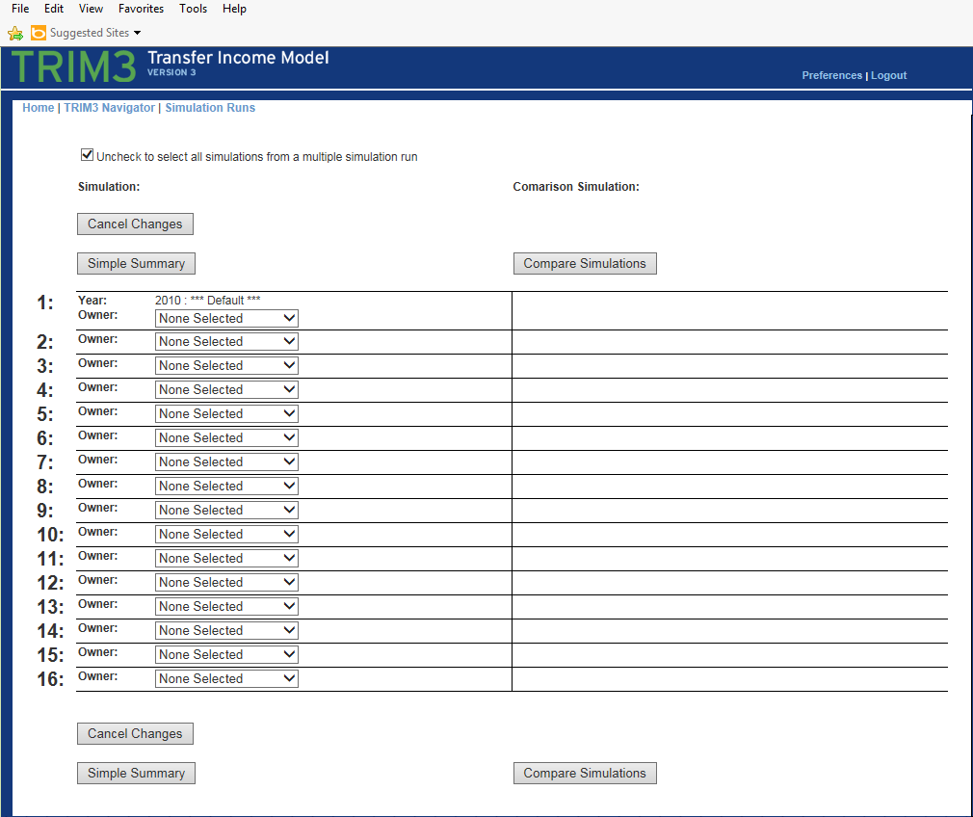

In column 1, select the “owner” of the first simulation whose results you want to summarize. Once you do, all run setups with micro-data in the TRIM3 database for the person you have selected in the year of your current run setup will be listed. You will be able to select from that list the run, and the simulation within that run, whose results you want to summarize.

If the simulations you want to either summarize or compare are in a multi-simulation run setup(s), then you can uncheck the box at the top of the page, select the multi-run setup, and the interface will automatically fill the boxes with each of the simulations that are in the multi-run setup you specified that have micro-results.

When your first column 1 “baseline” selection has been made, you will see that the simulation interface makes available the same selection options for column 2, where “alternative” simulations are chosen. If you want to compare a simulation with one in column 1, then select another simulation of the same simulation type (e.g. TANF or SSI) in column 2 of the same row. If you specify a comparison simulation(s), SummaryTables will produce tables comparing column 2 results with those from column 1; otherwise, only summary tables for column 1 simulations will be generated.

Required Variables by Module
The table shown below indicates the required results variables that must be available in the micro-data of the simulations an analyst selects for SummaryTables tabulations.

ChildCare | ChildCareSubsidy, ChildCareExpense, IsFamilyEligible
ChildSupport | MonthlyCSIncomeOfChild, MonthlyCSInHhsWithoutKids
Liheap | LiheapEligibility, LiheapBenefitRcvd
FederalTax | Tax
PubOrSubsidizedHousing | MonthlySubsidyReceivePerPerson
Medicaid | EnrollmentType
PayrollTax | WorkerFedRetireTax, WorkerOASDHI, SelfEmpOASDHI
FoodStamps | BenefitsReceived, BenefitsEligibleFor
SSI | MonthlySSIBenefitsRcvd
StateTax | StateTax
TANF | BenefitsReceived, BenefitsEligibleFor
UnemploymentCompensation | MonthlyUnemploymentComp
WIC | MonthlyWICBenefitRcvd
SchoolMeals | MonthlyRcvdSchoolMealSubsidies, MonthlyEligSchoolMealSubsidies

Unit Definition
One question that faced analysts when designing the SummaryTables module was how to deal with all the different unit definitions in the simulations that the module summarizes. As an example, the SNAP unit may be a household unit or a modified household unit, whereas the child care unit is typically the narrow family or a modified unit in which two or more narrow family units have been merged into one. The tax modules define units in unique ways, consistent with tax laws. The resolution was to reduce all simulated information to the person-level and then form either “narrow” or “broad” family units as defined by TRIM3 variables FamilySubfamiliesSeparate and FamilyWithSubfamilies for the purpose of the summary tabulations. SummaryTables program rule FamilyType provides analysts with the ability to use either definition for the tables that are generated.

Another rule, CohabitingAdultOption, provides analysts with the option of combining the families of cohabiting adults when both are biological parents of a minor child in the household. If an analyst chooses to combine families of cohabiting parents, then variables that identify the parents must be provided for the ParentIDs program rule.

User-specified Program Rules
The SummaryTables module has few rules that are specified by users, but in addition to the rules that determine how families are defined, two additional rules that analysts need to specify are PovertyRate and CashIncome. PovertyRate is used to identify the family poverty rate variable that is used for the summary tables, and CashIncome holds the components of cash income used for the family income measure. All rules in the “Simulation Selection” category are automatically filled by the SummaryTables interface when a user selects the simulations that are to be summarized.

In narrowly defined families, related subfamilies are separate from primary families.
In broadly defined families, related subfamilies are combined with primary families and treated as a single family unit.

